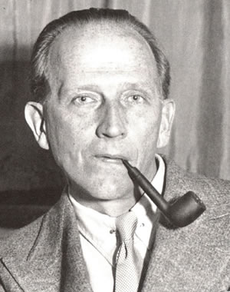
WHAT A CHARACTER
Match the Author & the Character (anagram)
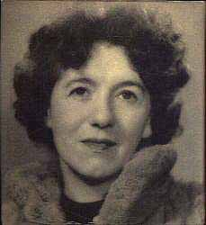
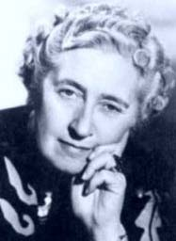
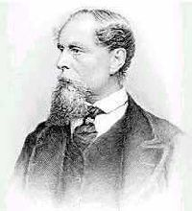
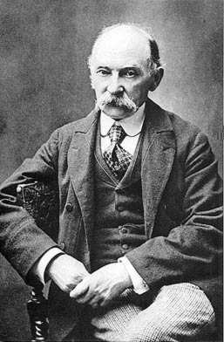




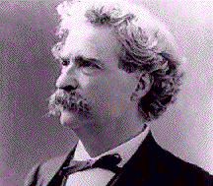

1. ROO PIT

2. BIG ARSE

3. GO BIRT HERB

4. PAY THE ROTRR

5. I TELL LENTL

6. BLOBI GIN BAGS

7. SORE WAY TM

8. OIL RAG BAKE

9. POOH IN THE WINE
10. CLAY HARD TETLEY

